**HOMEVERSE REAL ESTATE MANAGEMENT SYSTEM**

**BY**

**SHADRACK KISOYAN**

**A REAL ESTATE PROJECT SUBMITTED IN PARTIAL FULFILLMENT OF THE REQUIREMENTS FOR THE AWARD OF BACHELORS DEGREE IN INFORMATION TECHNOLOGY**

**SCHOOL OF SCIENCE,ENGINEERING AND TECHNOLOGY**

**KABARAK UNIVERSITY**

**AUGUST 2023**

**Declaration**

I Shadrack Kisoyan declare that this is my original work and has not been presented in any other university or any other institution of higher learning for examination purposes.

Signature: ……………………………… Date: ………………………………

**SHADRACK KISOYAN**

DIT/N/0243/01/22

This Real Estate Project has been submitted with my approval as the Supervisor of Kabarak University.

Signature: ……………………………… Date: ………………………………

**DON ARTKINS**

SCHOOL OF SCIENCE, ENGINEERING AND TECHNOLOGY

DEPARTMENT OF TECHNOLOGY

KABARAK UNIVERSITY

**Dedication**

To my dear parents, my siblings and my special friends,for all their love, support and advice.

**Acknowledgment**

I acknowledge the almighty God for seeing me through the entire project. I thank my supervisor, Madam Loraine, for the guidance she gave me during study time and the project development period. Her valuable recommendations have guided me to produce a management system that I am proud to be part of. I also appreciate the support from my family, friends, my lecturers and classmates for all the support that made it possible for me to complete this project. I would also like to appreciate those who took part in this project process for their time patience and support, without their support this work wouldn’t have been a success. Lastly I thank Kabarak University administration, lecturers, staff, and the students for their support.

**Abstract**

Homeverse Real Estate Management System is a web application that allows one to access information about real estate property, submit property, buy property and rent property.

The system also records information of user orders and reviews and login in details. The project includes four main tables; user, property, reviews and orders. It also includes four forms; submit property, add review, order and contact.

The admin page focuses on managing admins, properties, blogs, reviews and orders. Each user, an admin and a normal user, is given a user id and password, which identifies them uniquely. The user is given a register form to create an account and a login form to enter the login details. The admin is not given a registration form but can only be added by an admin. Each user can change the password, change profile picture.

The users can also search their desired property and view all details about it in the property page. The whole project makes work easier for every person in need of a house to rent or buy or any other real estate property.

CHAPTER ONE 6

INTRODUCTION 6

Background 6

Problem Statement 7

Proposed System 8

Justification 8

Objectives 9

Scope 9

CHAPTER TWO 10

SYSTEM ANALYSIS AND FEASIBILITY STUDY 10

Introduction 10

Feasibility Study 10

Operational Feasibility Study 10

Economic Feasibility 11

Estimated cost 11

Technical Feasibility 12

Design Methodology 13

Data Collection 13

Questionnaires 13

Observation 14

Data Analysis Procedure 14

Questionnaires 14

User Questionnaire Sample 15

Questionnaire Analysis 16

User Preference 17

Male pie chart 17

Female pie chart 17

Overall Bar Graph 17

CHAPTER THREE 18

SYSTEM DESIGN 18

Introduction 18

System Design 18

Physical design 18

Logical Design 21

Process Design 23

User 23

Administrator 24

System Flow Chart 25

OUTPUT DESIGN 26

Admin Login Page 26

User Login Page 26

User Register Page 26

INTERFACE DESIGN 27

Admin Dashboard 27

Admin Manage Property Page 27

Admin Manage Order Page 27

Home Page 27

Profile Page 28

About Page 28

Services Page 28

Property Page 28

Blog Page 28

Contact Page 28

STORAGE DESIGN 28

User Table 28

Property Table 29

Reviews Table 29

Orders Table 29

CHAPTER FOUR 30

INTRODUCTION 30

User Documentation 30

Administrator 30

Regular User 31

CHAPTER FIVE 32

INTRODUCTION 32

Type of Test 32

Unit Testing 32

Intergration Testing 33

Install/Uninstall Testing 33

System Testing 33

Interface Testing 34

Acceptance Testing 34

REFERENCES 35

APPENDICES 36

Questionnaire Appendix I 36

Time Schedule Appendix II 38

Budget Appendix III 39

Sample Code Appendix V 40

Home Page Sample Code 40

# CHAPTER ONE

## INTRODUCTION

### Background

Background study in the realm of real estate has illuminated the ever-evolving landscape of property transactions. Recent reports highlight the dynamic challenges faced by both buyers and sellers in the current real estate market. Among these challenges, the need for an automated system to streamline and enhance the efficiency of property transactions has become increasingly evident.

In an era where convenience and speed are paramount, traditional methods of property management and transactions are showing their limitations. Headlines often feature stories of prospective buyers struggling to find their ideal properties a midst a sea of listings, while sellers find it equally daunting to connect with potential buyers who match their property criteria. The demand for an innovative solution that revolutionizes how real estate is bought, sold, and managed is at the forefront of this changing landscape.

The world of real estate, necessitates a centralized repository of information and efficient communication channels. An automated system in the real estate domain aims to serve as a repository for property listings, buyer preferences, seller specifications, and transaction histories. This modern approach seeks to simplify the process of connecting prospective buyers with suitable properties, facilitating seamless transactions, and ultimately reshaping the dynamics of property exchange.

An advanced automated system within the real estate sector has the potential to transform how people find their dream homes and manage property transactions. By harnessing technology to create a comprehensive platform, the Homeverse Real Estate automated system project aspires to usher in a new era of convenience, transparency, and efficiency in the world of property transactions.

## Problem Statement

Most real estate in Kenya use the manual system for renting, buying and selling property. With the manual system, there are problems in managing the property records and orders. The property records and orders might not be kept safely and there might be missing of property records or orders due to human error or disasters.

There is no centralized database of all the property. So, it becomes really tedious for a person to search a desired property in case of emergency. The only option is to manually search all the properties and compare to find a perfect match to their desire and then make phone calls to every property owner for enquiries about prices. This process is not only tiresome but also time consuming.

## Proposed System

I propose a central real estate management system that helps the people who are in need of a property by linking them directly to the property owners. Users can get information of their desired any time. New users can also get registered and be able to access all property details.

The system will increase speed in terms of property record searching, reduce time spent on paper work, accuracy of data hence there will be no redundancy of data and it be will easy to handle/operate.

## Justification

This project is a web-based database application system that is to be used by the real estate companies as a means to advertise the nationwide best property to the public and at the same time allow the public to make online request for property.

The system keeps the record of all the property, orders, reviews and blogs about the property. This project intends to computerize the real estate management system in order to improve the record management efficiency due to the grown size of records of data.

## Objectives

1. To allow the probable users to make search and view details of desired property.
2. To provide an efficient real estate management system by recording the user and property details.
3. To provide a synchronized and centralized property database.

## Scope

The system will be a web based application. The system is used for maintaining all the process and activities of real estate management system and it also takes care of the details of the users and properties. There are several users with different privileges. Administrator: has full privilege on the system's functions, Public: can view the property, add property and make reviews on property.

# CHAPTER TWO

## SYSTEM ANALYSIS AND FEASIBILITY STUDY

### Introduction

System analysis is the process of gathering and interpreting facts, diagnosing problem and the information to recommend improvement on the system. The system analyst play the role of the interrogator and the dwells deep into working of the present system identified. The output form the system are traced to the various process

### Feasibility Study

The analyst carried out study to determine whether the proposed system is viable or not. The study showed that the proposed system is viable because the system is able to solve frequent problems encountered. Some of the areas which were covered during the study are outlined below:-

### Operational Feasibility Study

Operational feasibility deals with issues such as whether the system will be used if it is developed and implemented. Whether there will be resistance from users that will affect the possible application benefits. Some of the essential questions that help in testing the operational feasibility of a system are:

2.2.1.1 Does the Government support such project?

2.2.1.2 Is the project/system user-friendly?

2.2.1.3 Will it reduce the time (operation) considerably?

2.2.1.4 Are the users not happy with current operational system?

If yes, then they will welcome the change and the new system.

This will be achieved by having the users involved in the planning and development of the system. This will be done by asking the various users of the system on their views concerning the various functionalities the system is to have.

Early involvement reduces the probability of resistance towards the new system.

### Economic Feasibility

#### Estimated cost

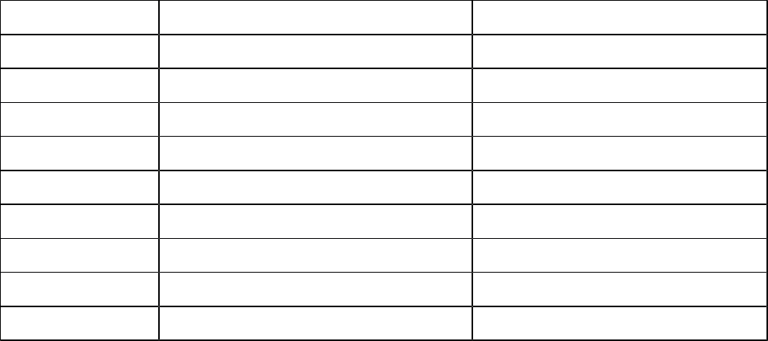

|  |  |  |
| --- | --- | --- |
| **S.NO** | **ITEM/OTHER COSTS** | **COST (ksh)** |
| 1 | 1 computer(laptop) | 40,000 |
| 2 | Printer | 30,000 |
| 3 | Antivirus | 1,000 |
| 4 | Modem | 1,000 |
| 5 | Internet bandwidth | 1,000 |
| 6 | Maintenance cost | 12,000 |
| 7 | Miscellaneous cost | 10,000 |
| 8 | Deployment cost | 2,000 |
| TOTAL | - | 97,000 |

The estimated cost for developing the system is 97,000 including the hardware devices needed for testing also. The benefits that the system will give to the community is more and it will reduce the high cost of money used to purchase document files that cost 100,000 for one year, carbon papers that cost 20,000 for one year, pens A4 size papers for writing that both cost 60,000 again for one year. Therefore, by using return on investment (ROI) we can have the following

ROI = (capital gains – cost of investments’) / cost of investments’

Cost of investments’ (estimated cost) =97,000

Capital gains (capital used on the current system to carry out operations) = 50,000+25,000+60,000 = 135,000

ROI = (135,000 – 97,000)/97,000

135,000 – 97,000 = 38,000

38,000/97,000 = 0.391752577

If viewed as percentage = 39.18% return on investments’

From the above feasibility, the development of the proposed system will be of great profit as it will save 39.18% of the yearly costs incurred with the manual process.

### Technical Feasibility

Technical Feasibility Study assesses the details of how a product will be delivered that is the materials needed, labor, the technology needed among other things. The technology needed for this particular system is a well-equipped computer with an operating system, web browsers, XAMPP, storage, any antivirus. This software’s are readily available and only need be installed to allow the running of the system.

Current most people have the following:



|  |  |  |  |  |
| --- | --- | --- | --- | --- |
| Computers | Operating | Browsers | Ram | Rom |
|  | system |  |  |  |
| A | Windows | Chrome, | 4GB | 500GB each |
| desktops/Laptop |  | Mozilla, |  |  |
|  |  | explorer |  |  |

These computer specifications do satisfy the systems requirements and will allow smooth running of the system once implemented. The desktops also allow installation of several software’s such as xampp which is needed for connection to the database.

This feasibility determined that the system is technically feasible for implementation.

### Design Methodology

The methodology used is the object oriented systems analysis and design

which is the discipline of defining objects and their interactions to solve a problem

that was identified during analysis. It will be conducted in the following phases:

**Information Gathering (Inception) -** This phase involves the research

and gathering of information from relevant sources in order to get a clear understanding of the problem. The products of this stage will be passed on to

the analysis stage. The primary goal for this phase is to establish the case for

the viability of the proposed system

**Analysis Phase -** In this phase the research findings will be used to model at a conceptual level. The results obtained will help in coming up with an appropriate design that suits the problem.

**Design Phase -** Conceptual level will be used to come up with DFDs diagrams that represent the system and its functionality. The DFDs design models are a more detailed version of the design identified in the analysis phase.

**Construction Phase -** he design model will be translated into an actual system. It is also at this stage where the database will be constructed based on the Entity Relational Diagram or class diagram depending on whether it is a relational database or object oriented database.

### Data Collection

There were various tools used to perform the data collection and for this system, data was collected using observation and questionnaires.

#### Questionnaires

This is also referred to as survey, it is an instrument used for collecting data in survey research. They usually include a set of standardized questions that explore a specific topic and collect information about demographics, opinions and behavior. For the project, the questionnaires is used to target. The reason for conducting this questionnaire is to know some the problems they really go through.

#### Observation

Using observation, it was also a best way of collecting data. This was done directly with the subject knowing or unaware that they were being observed. While still observing the data was collected through continuous observation and the data gathered was interpreted using the following mechanisms.

2.4.2.1 Descriptive observations: here the observation was simply written down.

2.4.2.2 Evaluating observation: this was noted that during a recent study on most real estate companies users had to give their details by filling forms that wasted lot of time.

### Data Analysis Procedure

#### Questionnaires

Dear respondent, I am Shadrack Kisoyan pursing a degree in Information Technology at

Kabarak University. Below I have a questionnaire that I have designed to assist me

in data collection for my project in partial fulfillment for the award of degree in

Information Technology. Your responses are highly appreciated and any information given will be taken with outmost security and confidentiality. Thank you.

##### User Questionnaire Sample

Instructions:

1. Please put a tick in the box next to the answer of your choice or write in the space provided as the case may be.
2. Only tick in one box.
3. No answer is wrong.
4. Indicate your gender

Male Female

1. Indicate your age

18 – 30 31 - 40 41 - 50 51 and above

1. Have you ever rented, bought or sold a real estate property?

Yes No

* 1. If yes in (3) above, how was your experience with the real estate company?

Very Good Good Bad Very Bad

1. How long did it take you to find a good house or your desired property

20mins 40mins 1hr more than 2hrs

1. Do you prefer a manual way of record keeping or automated (use computers)?
   1. Give reasons for your answer above

____________________________________________________________

____________________________________________________________

____________________________________________________________

____________________________________________________________

____________________________________________________________

____________________________________________________________

____________________________________________________________

1. How long did it take you to finish the whole process of acquiring the property?

20mins 40mins 1hr more than 2hrs

1. Is providing a platform where a user who requires a house can get it easily by contacting the owner directly and getting real time information on the property a good approach?
   1. If yes in (7) above please give reasons.

____________________________________________________________

____________________________________________________________

____________________________________________________________

____________________________________________________________

____________________________________________________________

____________________________________________________________

____________________________________________________________

* 1. If no in (7) above please give reasons.

____________________________________________________________

____________________________________________________________

____________________________________________________________

____________________________________________________________

____________________________________________________________

____________________________________________________________

____________________________________________________________

Thank you for your time. God bless you.

#### Questionnaire Analysis

|  |  |  |
| --- | --- | --- |
| **Question** | **Response** | **No Response** |
| 1 | 50 | 0 |
| 2 | 48 | 2 |
| 3 a | 30 | 20 |
| 4 | 40 | 10 |
| 5 a | 20 | 30 |
| 6 | 45 | 15 |
| 7 a | 25 | 25 |
| 7 b | 48 | 2 |

Using the above questionnaire the critical issue was automation and response time

taken when making a query. Thus the development of the proposed system would

be of benefit and useful to a donor.

#### User Preference

|  |  |  |  |
| --- | --- | --- | --- |
| **Gender** | **Automated** | **Manual** | **Undecided** |
| **Male** | **73%** | **21%** | **6%** |
| **Female** | **66%** | **31%** | **3%** |

##### Male pie chart

##### Female pie chart

##### Overall Bar Graph

# CHAPTER THREE

## SYSTEM DESIGN

### Introduction

#### System Design

**Logical design**-in logical design, it shows the blueprint of the proposed system as how it will appear after the system has been developed.

**Physical design**-in physical design, it shows the blueprint of the proposed system as how it appears in the programmers mind.

##### Physical design

Login Form

In this form a user is asked to log in to his/her account to access his/her details. The system require them to log in using a valid email/ the registered one, that is, the one in the data base system. If not the user is required to register to the system

Login

Enter Username…….

Enter Password…….

Forgot Password?

Login

Dont have an account? Register

Registration Form

For a new user to access the system, one must, register into the system and an account is allocated. Few details are require to register.

Register

Enter Full Name……..

Enter Username…….

Choose Profile picture

Enter Email…….

Enter Phone…….

Already have an account? Login

Register

Admin

The admin has access to the system and the management power as compared to the other users. One can access admin list and add another admin. He can also view and manage property, blogs, reviews and orders.

Home

Manage Admin

Admin Admin

Update Admin

Delete Admin

Manage Property

Add Blog

Update Property

Delete Property

Manage Review

Update Review

Delete Review

Update Blog

Manage Blog

Delete Blog

Delete Order

Manage Order

Update Order

##### Logical Design

Use case diagram for administrator

Admin Admin

Update Admin

Delete Admin

Add Blog

Login

Manage Admin

Manage Review

Manage Property

Manage Blog

Manage Order

Delete Property

Update Property

Update Review

Delete Review

Update Blog

Delete Blog

Update Order

Delete Order

Use case diagram for user

Update Profile

Update Password

View Profile

Register

Login

Search Property

Add Property

Add Review

Make Order

#### Process Design

##### User

Login

Authenticated?

No

Yes

Home

Search Property

View Profile

Add Review

Make Order

Contact Us

##### Administrator

Login

Authenticated?

No

Yes

Home

Manage Property

Manage Admin

Manage Review

Manage Blog

Manage Order

##### System Flow Chart

Is Valid User?

No

Register

No

Start

Yes

Logout

Login

Is Registered User?

Yes

No

User?

Admin?

Yes

Submit Property

Search Property

Yes

Manage Admin

Manage Property

Add Review

Manage Blog

Manage Order

Make Order

Manage Review

View Profile

End

## OUTPUT DESIGN

This is used to show the system output as per how the user used the

system. The system process to data entered by the user to give full information to

the recipient.

### Admin Login Page

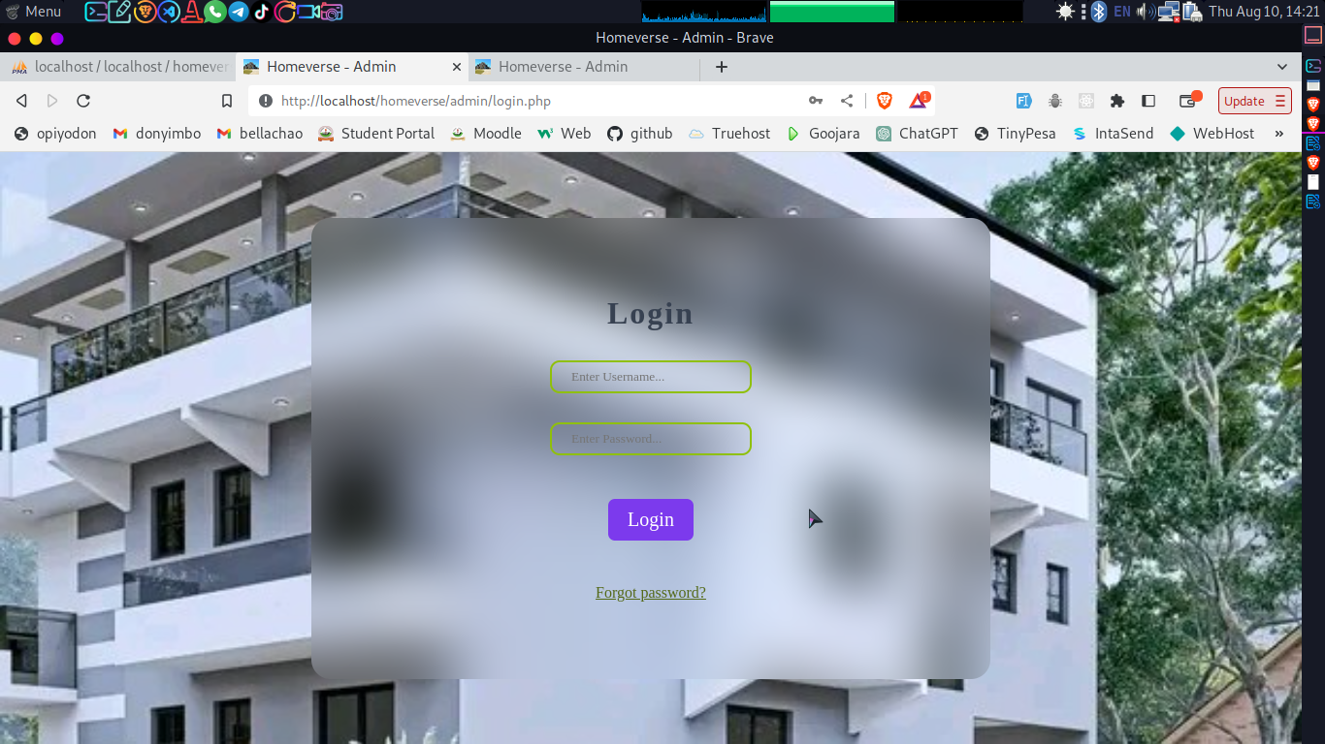

### User Login Page

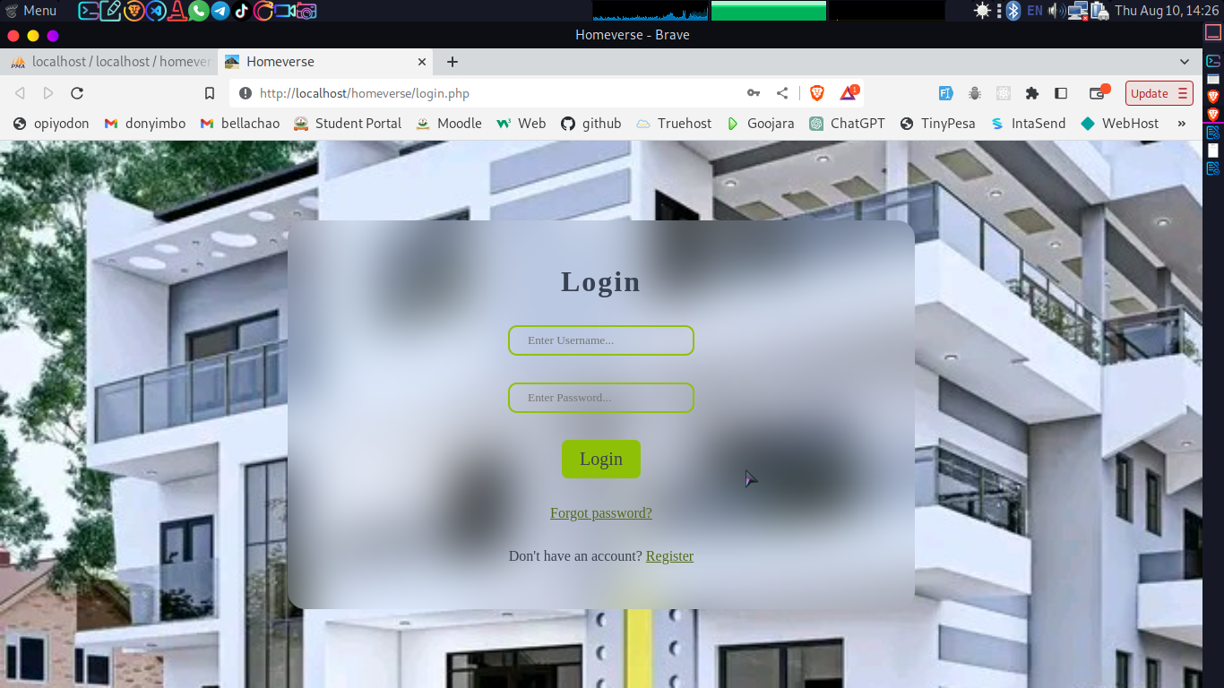

### User Register Page

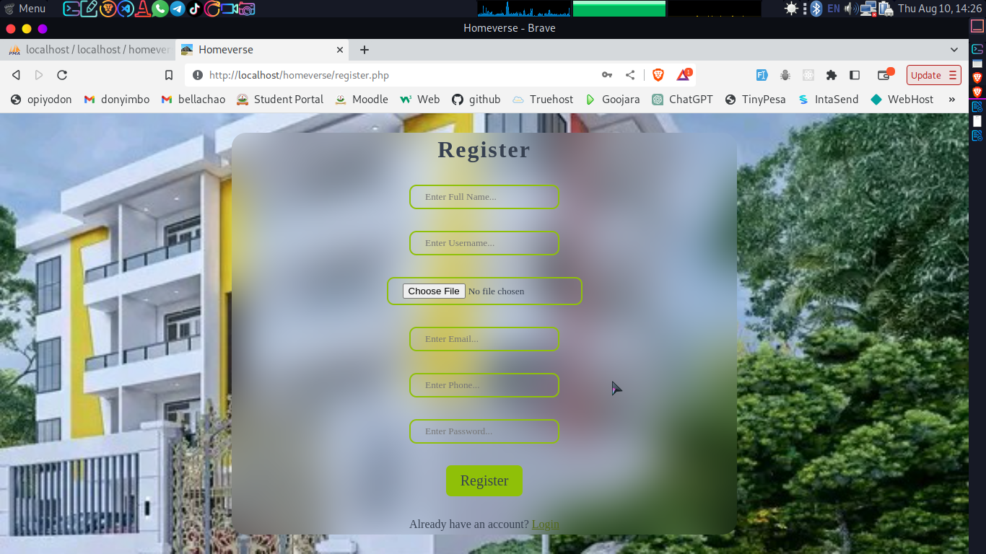

## INTERFACE DESIGN

After logging in, this is how the interface of the system looks.

### Admin Dashboard

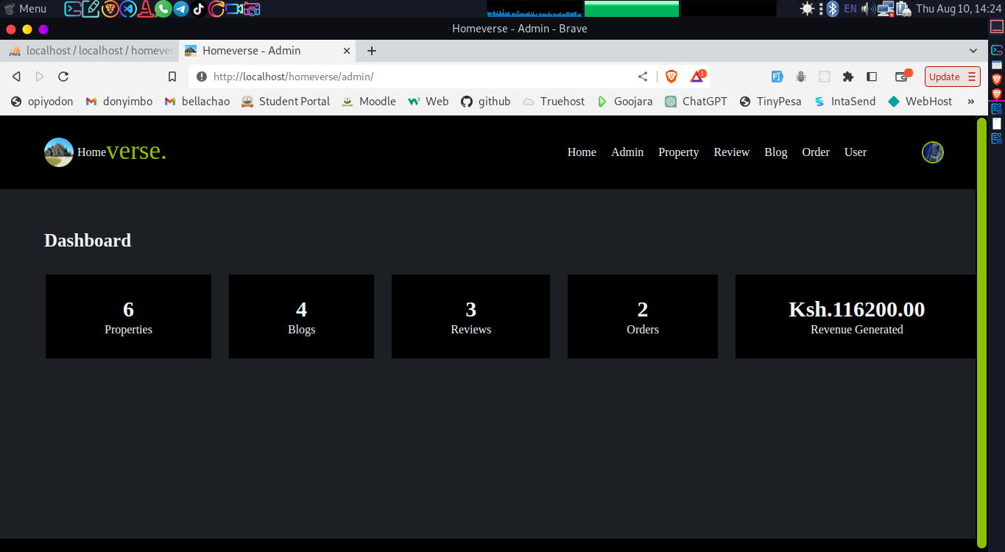

### Admin Manage Property Page

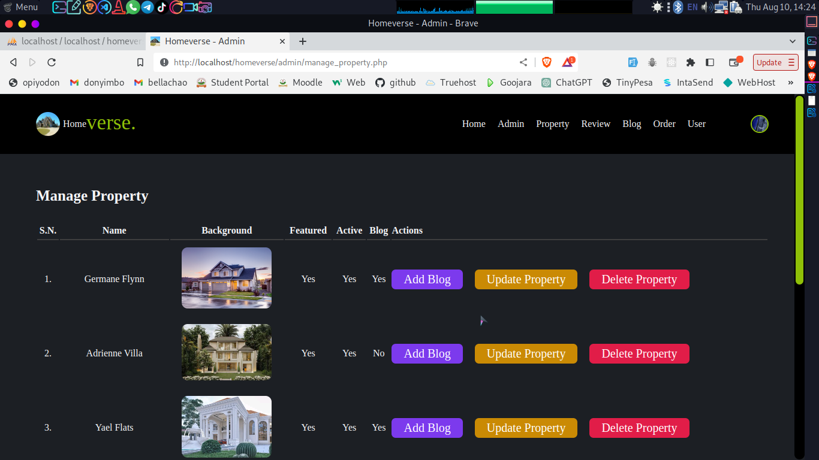

### Admin Manage Order Page

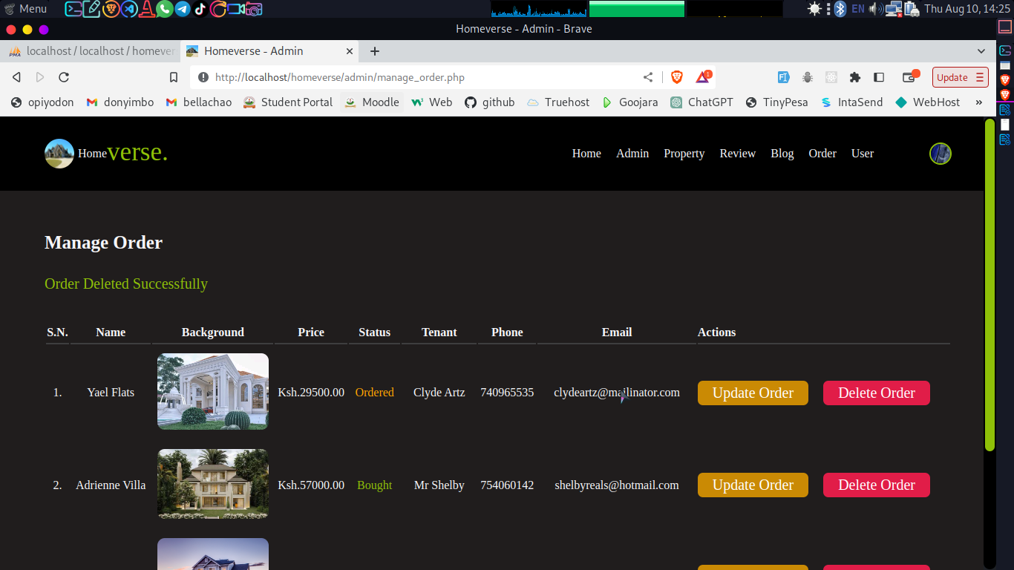

### Home Page

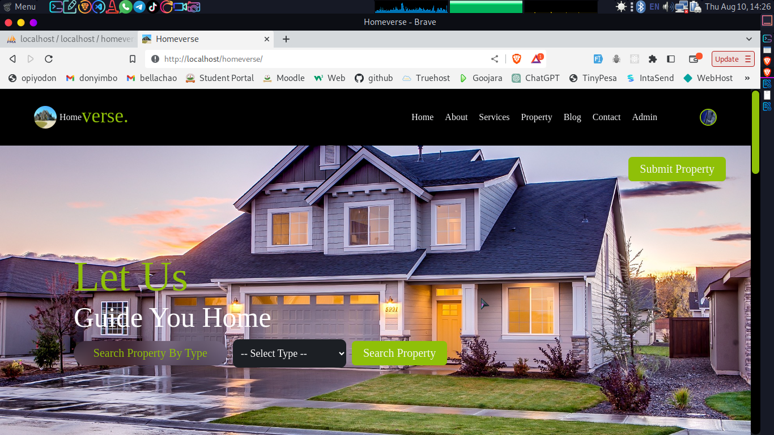

### Profile Page

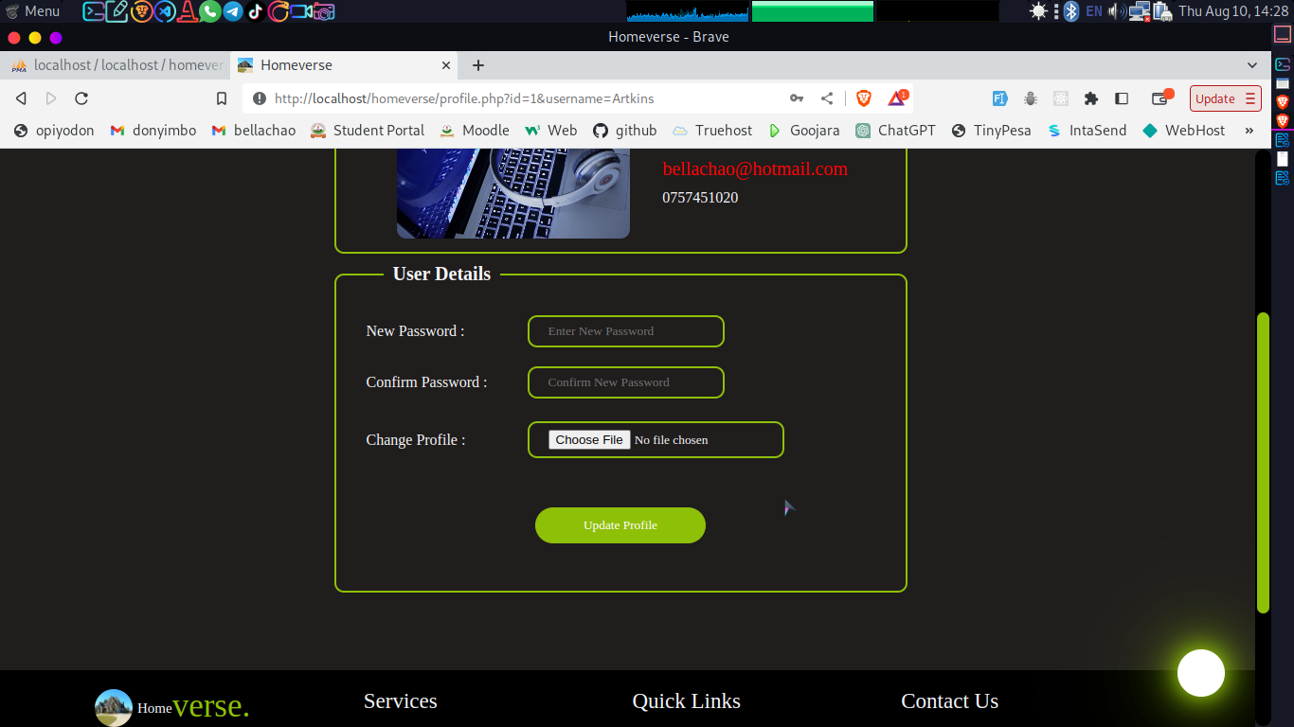

### About Page

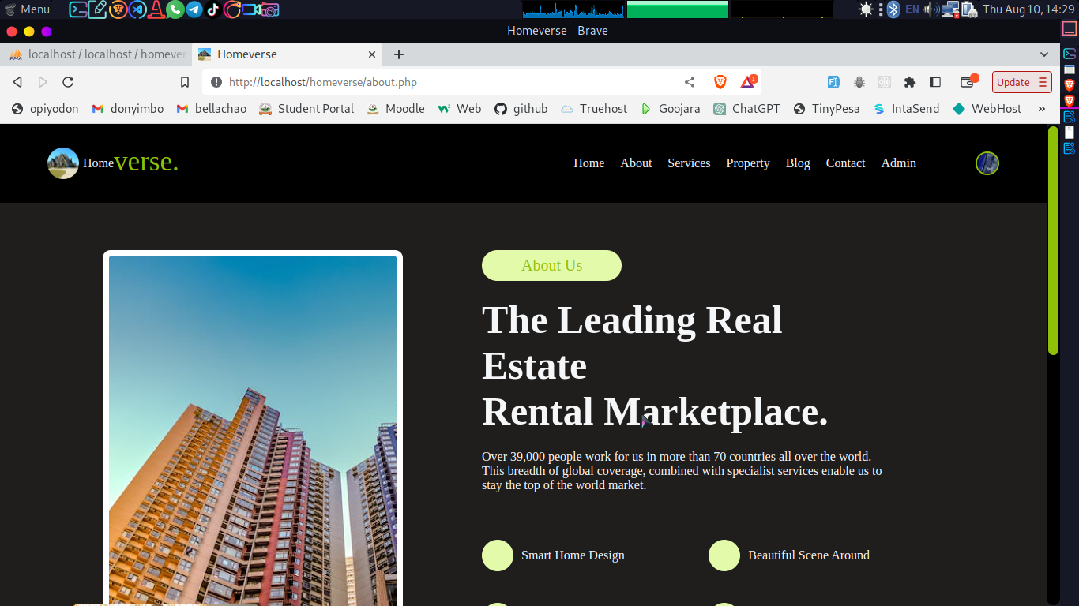

### Services Page

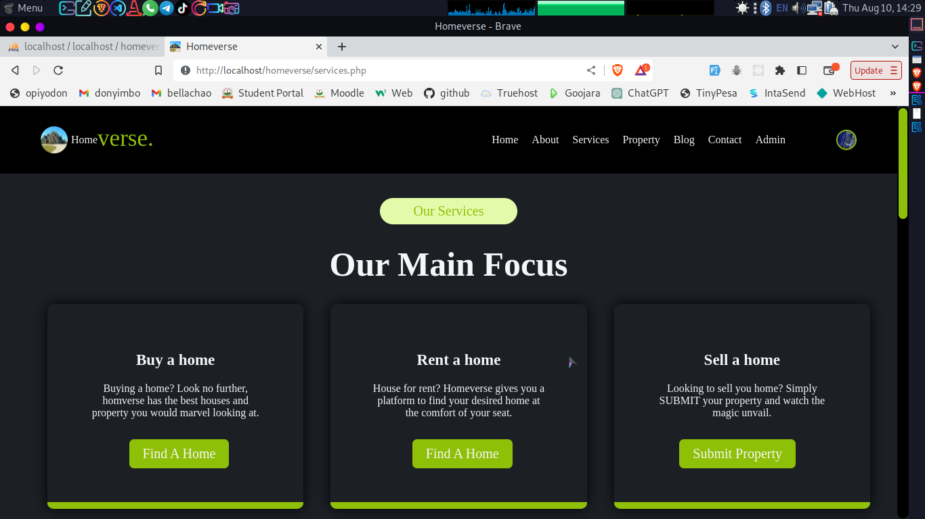

### Property Page

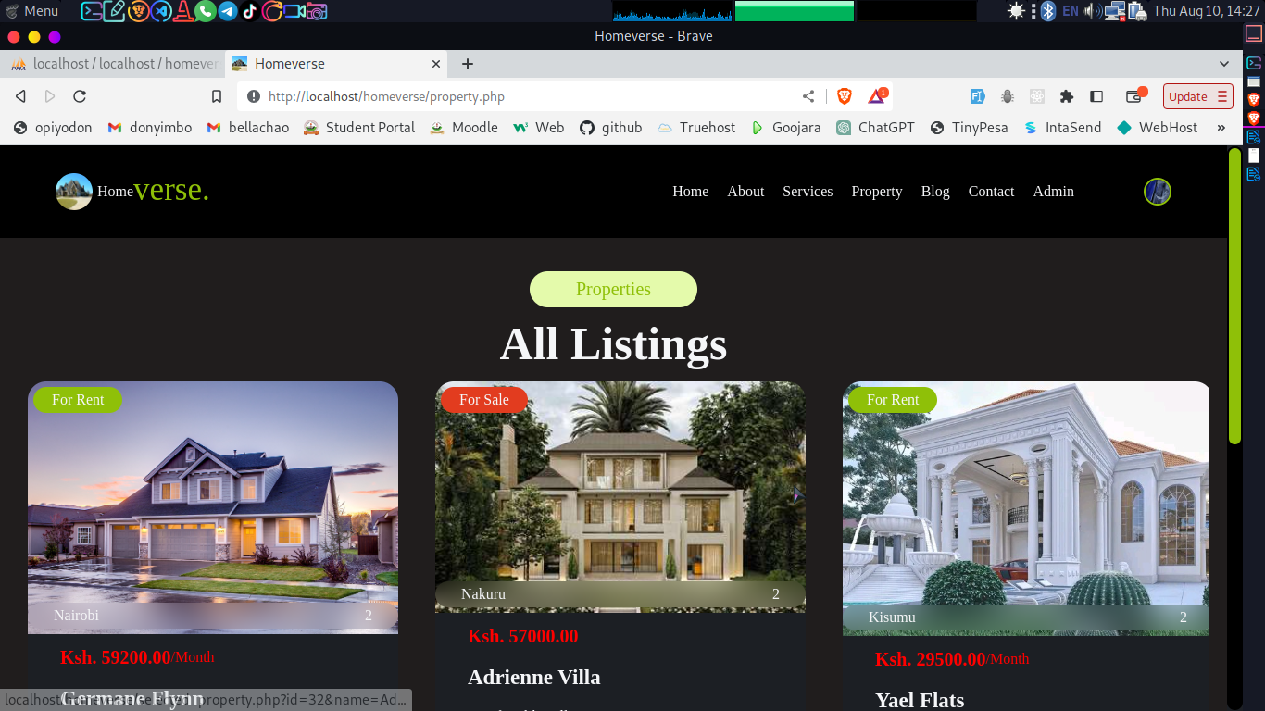

### Blog Page

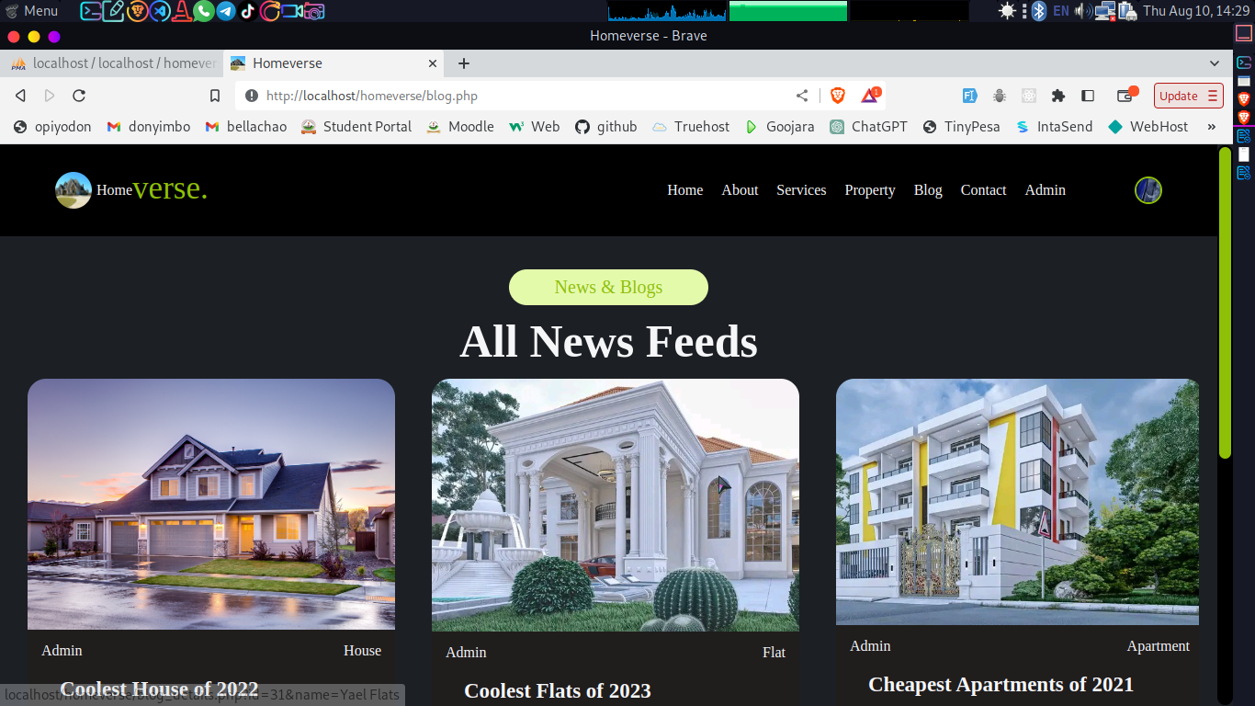

### Contact Page

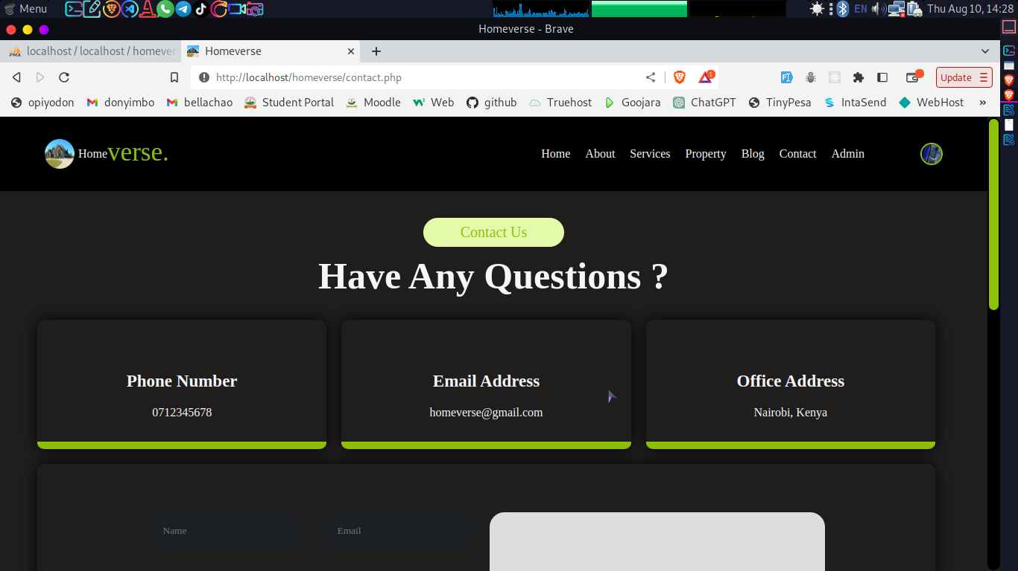

## STORAGE DESIGN

The database of this system includes four (4) major tables; user, property, reviews and order.

### User Table

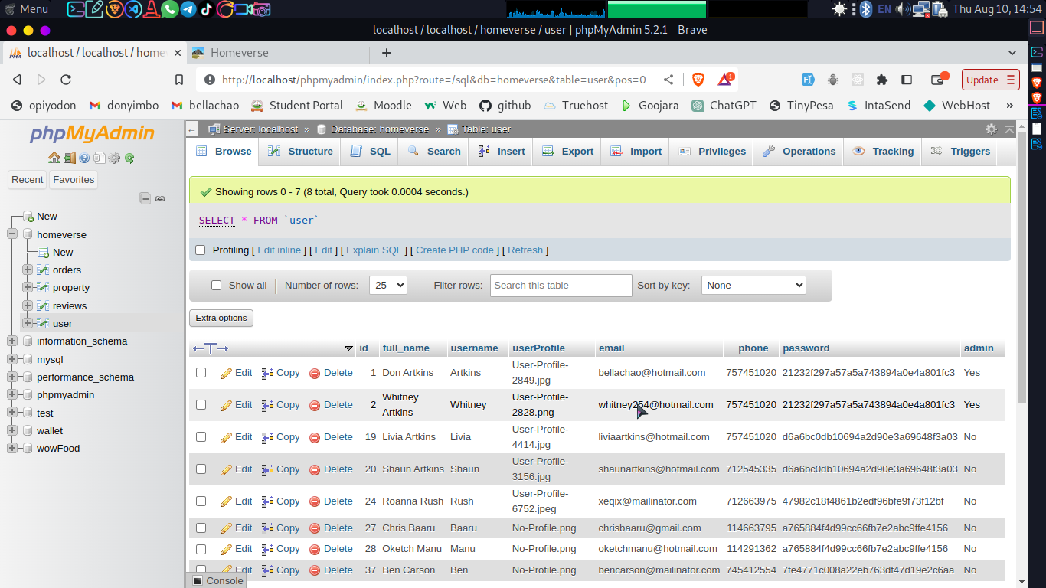

### Property Table

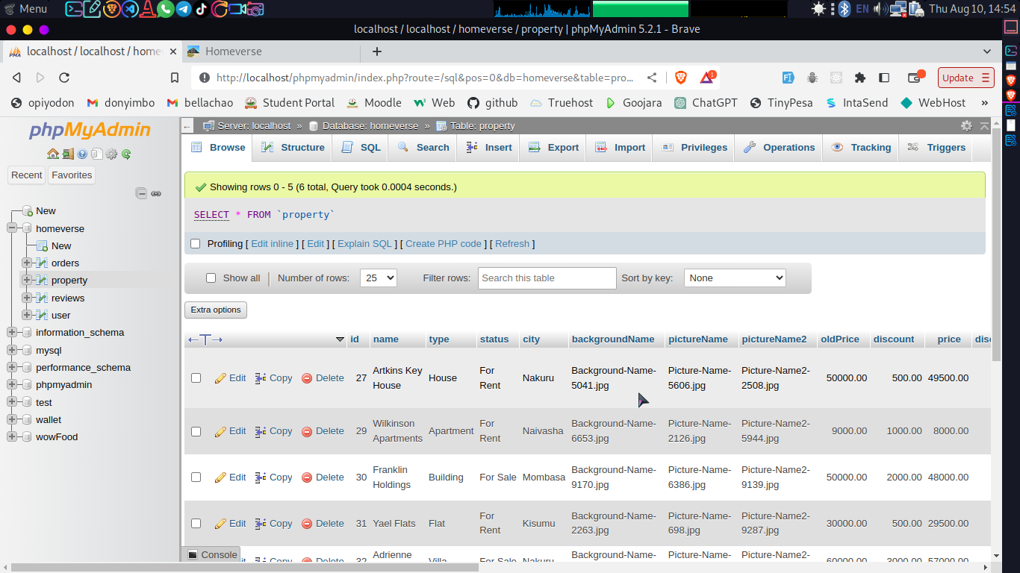

### Reviews Table

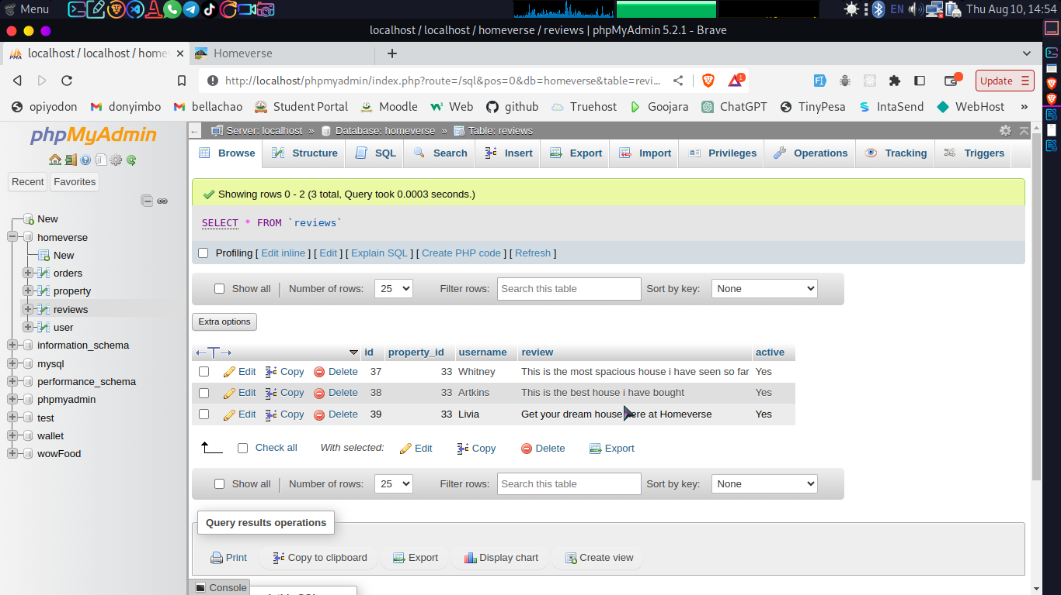

### Orders Table

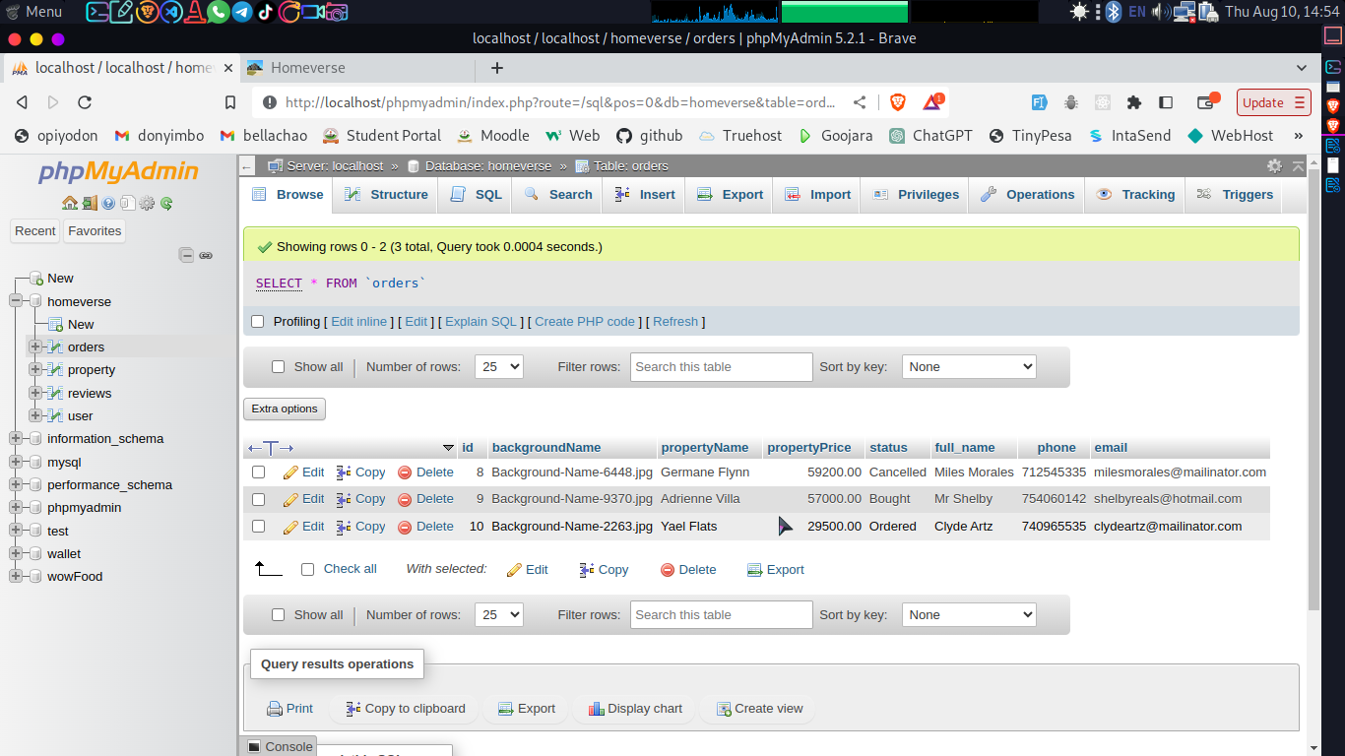

# CHAPTER FOUR

## INTRODUCTION

This chapter involves or explains how the system works for the users. It should explain what takes place in the system.

## User Documentation

### Administrator

This module is under the administrator control various functions operated by the admin:

* **Log in:** The whole system is under the control of the admin. A valid administrator is created and can operate the system using his/her account.
* **Manage Admin:** The administrator can manage all other admins including adding a new admin, delete admin account and updating admin account. .
* **Manage Property:** The administrator can update a property or add it to blog or delete property.
* **Manage Blog:** the admin can update blog and delete blog.
* **Manage Reviews:** the admin can update reviews and delete irrelevant reviews.
* **Manage Order:** the admin can update order and delete order.

### Regular User

A regular user can register an account and be able to do the following:

* **Log in:** A registered user can login to the system and be able to view everything but cannot log into the admins panel.
* **Add Property:** A registered user can add property by clicking the ‘SUMIT PROPERTY’ button.
* **Search Property: A** registered user can search for desired property on the home page.
* **Add Review: A** registered user can add a review to a particular property by clicking on the property.
* **Make order: A** registered user can make an order of desired property.

# CHAPTER FIVE

## INTRODUCTION

In this process of testing the whole system and integrated software. The purpose is to evaluate the system compliance with the specified requirement. These are several type of testing

## Type of Test

This is the process of testing complete and integrated software. The purpose is to evaluate the systems compliance with the specified requirements. There are several types of testing that can be done. The following tests were done:

### Unit Testing

This is a software verification and validation method in which a programmer tests if individual units of source code are fit for use.

|  |  |  |
| --- | --- | --- |
| **Test Area** | **Expected Results** | **Actual Results** |
| Logging In | A user with an account  should be able to log in | Users logged in successfully |
| Creating an Account | A users details should be  captured and stored | Users data captured and stored |
| Adding Property | A user (property owner)should be able to add property | Users we able to add various property to the system |
| Making Order | A user should be able to view properties and make an order | Users we able to make orders |

### Intergration Testing

This refers to testing in which individual software modules are combined

and tested as a group.

|  |  |  |
| --- | --- | --- |
| **Test Area** | **Expected Results** | **Actual Results** |
| Logging In | Valid users should get access to their accounts and invalid users should not be able to log in | with valid accounts were able to log in. Users with invalid accounts could not log in |
| Authorization | Users should be able  to get access to their  accounts details | Users could view  their details |

### Install/Uninstall Testing

Quality assurance work that focuses on what will be needed to do to install

and set up the new software successfully.

|  |  |
| --- | --- |
| **Objective** | **Achievement** |
| To test if the system can be installed and run on different computers | The system was installed on various machines and performed as expected |

### System Testing

Refers to the process of testing an integrated hardware and software

system to verify it meets its specified requirements.

|  |  |  |
| --- | --- | --- |
| **Test Area** | **Expected Results** | **Actual Results** |
| Full application | Create and log in into  an account and a user  should be able to  request or donate  blood | Accounts were  created and users  logged in and made  requests for donation  and receiving blood |
| Full application | The administrator should be able to log in, manage donors and recipients, view donor lists | The administrator logged in and performed tasks such as view the donor list, approving a donor |

### Interface Testing

Testing conducted to evaluate whether systems or components pass data

and control correctly to one another.

|  |  |  |
| --- | --- | --- |
| **Test Area** | **Expected Results** | **Actual Results** |
| Log in | Once a user log in a new page should be loaded where they can view the home page | Users who logged in could view the home page on a new page |

### Acceptance Testing

Formal testing conducted to determine whether or not a system satisfies its

acceptance criteria and to enable the customer the system.

|  |  |
| --- | --- |
| **Objective** | **Achievement** |
| The new system will enhance security by limiting access to the system | The new system had passwords which limited unauthorized users from accessing it |
| The system will allow fast data search for house and other property | All registered users and their records can be easily found. |

# REFERENCES

1. Smith, J. A. (2020). Evolving Trends in Real Estate Transactions. Property Management Journal, 45(3), 210-225.
2. Brown, L. M. (2019). Innovations in Property Management Systems. Real Estate Technology Review, 32(2), 87-102.
3. Williams, R. D. (2021). Modernizing Real Estate Transactions through Automation. Journal of Property Exchange, 15(4), 320-335.
4. Johnson, E. K. (2018). The Role of Technology in Revolutionizing Real Estate. In Technology and Real Estate Symposium Proceedings (pp. 78-89).
5. Martinez, S. P. (2022). Transforming Property Transactions: A Case Study of XYZ Real Estate System. Real Estate Transformation Journal, 50(1), 45-60.
6. Homeverse Real Estate. (2023). Project Proposal for an Automated Real Estate System. Unpublished internal document.
7. Garcia, M. N., & Lee, A. R. (2019). Technology-Driven Innovation in Real Estate: A Survey of Industry Professionals. International Journal of Real Estate Management, 38(3), 201-220.
8. Harris, P. Q. (2021). Enhancing Transparency in Real Estate Transactions through Automation. Journal of Property Technology, 27(4), 310-325.

# APPENDICES

## Questionnaire Appendix I

Instructions:

1. Please put a tick in the box next to the answer of your choice or write in the space provided as the case may be.
2. Only tick in one box.
3. No answer is wrong.
4. Indicate your gender

Male Female

1. Indicate your age

18 – 30 31 - 40 41 - 50 51 and above

1. Have you ever rented, bought or sold a real estate property?

Yes No

* 1. If yes in (3) above, how was your experience with the real estate company?

Very Good Good Bad Very Bad

1. How long did it take you to find a good house or your desired property

20mins 40mins 1hr more than 2hrs

1. Do you prefer a manual way of record keeping or automated (use computers)?
   1. Give reasons for your answer above

____________________________________________________________

____________________________________________________________

____________________________________________________________

____________________________________________________________

____________________________________________________________

____________________________________________________________

____________________________________________________________

1. How long did it take you to finish the whole process of acquiring the property?

20mins 40mins 1hr more than 2hrs

1. Is providing a platform where a user who requires a house can get it easily by contacting the owner directly and getting real time information on the property a good approach?
   1. If yes in (7) above please give reasons.

____________________________________________________________

____________________________________________________________

____________________________________________________________

____________________________________________________________

____________________________________________________________

____________________________________________________________

____________________________________________________________

* 1. If no in (7) above please give reasons.

____________________________________________________________

____________________________________________________________

____________________________________________________________

____________________________________________________________

____________________________________________________________

____________________________________________________________

____________________________________________________________

**Thank you for your time. God bless you.**

## Time Schedule Appendix II

|  |  |  |  |  |  |  |
| --- | --- | --- | --- | --- | --- | --- |
| **Activity** | **No of Hours** | **Proposal Start Date** | **Proposal End Date** | **Actual Start Date** | **Actual End Date** | **Deliverables** |
| Fact Finding | 20 | 6/6/2023 | 8/6/2023 | 15/6/2023 | 20/6/2023 | Facts collected |
| Problem Definition | 25 | 16/6/2023 | 21/6/2023 | 25/6/2023 | 30/6/2023 | Problems associated current manual system identified |
| Proposal Compilation | 25 | 22/6/2023 | 23/6/2023 | 2/7/2023 | 5/7/2023 | Compiled and printed |
| Data Collection | 35 | 25/6/2023 | 30/6/2023 | 10/7/2023 | 30/7/2023 | Data collected through questionnaire |
| System Analysis | 20 | 2/7/2023 | 5/7/2023 | 1/7/2023 | 6/7/2023 | Feedback from questionnaire analyzed |
| System Design | 25 | 10/7/2023 | 30/7/2023 | 7/7/2023 | 14/7/2023 | Models designed |
| Coding and Testing | 200 | 1/7/2023 | 6/7/2023 | 16/7/2023 | 23/7/2023 | Errors identified and corrected |
| Documentation | 35 | 7/7/2023 | 14/7/2023 | 25/7/2023 | 29/7/2023 | Documentation of the project  stages |

## Budget Appendix III

|  |  |  |  |  |
| --- | --- | --- | --- | --- |
| **Serial No** | **Item** | **Quantity** | **Price per item** | **Justification** |
| 1 | Transport |  | 3. 500 | For system  requirements  collection |
| 2 | Software Resourses | Kaspersky  Operating  System | 1, 000  1, 500 | For developing the  system |
| 3 | Hardware Resourses | Hard disk-500GB  Laptop  Modem | 5, 000  37, 000  3, 500 | For running and  developing the  system |
| 4 | Internet |  | 2, 000 | Research |
| 5 | Miscellaneous  expenses |  | 6, 500 | For unaccounted  extra costs inquired |
| **TOTAL** |  |  | **60, 000** |  |

## Sample Code Appendix V

### Home Page Sample Code

**<?php include('partials/nav.php'); ?>**

<!--===========================================================HOME SECTION START====================================================-->

<section id="Home">

<a name="Home">

<div class="HOME">

<div class="submit">

<a href="<?php echo SITEURL_USER; ?>add_property.php" class="btn btn-submit">Submit Property</a>

</div>

<?php

if(isset($_SESSION['login']))

{

echo $_SESSION['login'];

unset($_SESSION['login']);

}

if(isset($_SESSION['profile']))

{

echo $_SESSION['profile'];

unset($_SESSION['profile']);

}

if(isset($_SESSION['add']))

{

echo $_SESSION['add'];

unset($_SESSION['add']);

}

?>

<div class="home-text">

<div>

<p class="TXT1">Let Us</p>

<p class="TXT2">Guide You Home</p>

</div>

<div>

<form action="<?php echo SITEURL_USER; ?>property_search.php" method="POST" class="SEARCH-FORM">

<div class="SEARCH_GROUP">

<div class="BACK">

<p class="text-primary">Search Property By Type</p>

</div>

<select required name="type" id="type" class="SEARCH_CONTROL bg-light_bg_bright2">

<option disabled selected value="Select_Type">-- Select Type --</option>

<?php

//query to get all admin

$sql3 = "SELECT DISTINCT type FROM property ORDER BY id DESC";

//execute the query

$res3 = mysqli_query($conn, $sql3);

//check whether the query is executed or not

if($res3==TRUE)

{

//Count rows to check whether we have data in database or not

$count3 = mysqli_num_rows($res3);//function to get all rows in the database

//check the num of rows

if($count3>0)

{

//we have data in database

while($rows3=mysqli_fetch_assoc($res3))

{

//using while loop to get all the data from database

//and while loop will run as long as theres data in database

//get individual data

$type=$rows3['type'];

//displaying the values in our table

?>

<option><?php echo $type ?></option>

<?php

}

}

else

{

?>

<option><div class="ERROR">We Do Not Have Data in Database.</div></option>

<?php

}

}

?>

</select>

<div class="SEARCH_BUTTON py-5">

<input type="submit" name="submit" class="btn" value="Search Property">

</div>

</div>

</form>

</div>

</div>

</div>

</a>

</section>

<!--===========================================================HOME SECTION END====================================================-->

<!--===========================================================PROPERTY SECTION START====================================================-->

<section id="Property">

<a name="Property">

<div class="PROPERTY">

<div class="ROW">

<div>

<p class="SECTION_TITLE">Properties</p>

</div>

</div>

<div class="PROPERTY_TITLE">

<p>

Featured Listings

</p>

</div>

<a href="<?php echo SITEURL_USER; ?>property.php">

<div class="MORE">

<div>

<button class="btn">All Listings</button>

</div>

</div>

</a>

<div class="CARD_BOX2">

<?php

//query to get all admin

$sql = "SELECT * FROM property WHERE featured='Yes' ORDER BY id DESC LIMIT 3";

//execute the query

$res = mysqli_query($conn, $sql);

//check whether the query is executed or not

if($res==TRUE)

{

//Count rows to check whether we have data in database or not

$count = mysqli_num_rows($res);//function to get all rows in the database

$sn=1;//create a variable and assign the value

//check the num of rows

if($count>0)

{

//we have data in database

while($rows=mysqli_fetch_assoc($res))

{

//using while loop to get all the data from database

//and while loop will run as long as theres data in database

//get individual data

$id=$rows['id'];

$name=$rows['name'];

$type=$rows['type'];

$status=$rows['status'];

$city=$rows['city'];

$backgroundName=$rows['backgroundName'];

$pictureName=$rows['pictureName'];

$price=$rows['price'];

$bedrooms=$rows['bedrooms'];

$bathrooms=$rows['bathrooms'];

$squareFt=$rows['squareFt'];

$description=$rows['description'];

$featured=$rows['featured'];

$active=$rows['active'];

$duration=$rows['duration'];

//displaying the values in our table

?>

<a href="<?php echo SITEURL_USER; ?>selected_property.php?id=<?php echo $id; ?>&name=<?php echo $name; ?>">

<!-- ===============UPDATE CARD THEN DELETE ||| START============ -->

<div class="cadz">

<div class="CARD_IMG">

<img src="images/property/background/<?php echo $backgroundName; ?>" alt="<?php echo $backgroundName; ?>">

<div class="STATUS">

<?php

// status

if($status=="For Rent")

{

echo "<div class='BADGE' style='background: var(--primary);'>$status</div>";

}

elseif($status=="For Sale")

{

echo "<div class='BADGE' style='background: var(--red);'>$status</div>";

}

?>

</div>

<div class="CITY">

<div class="ROW">

<div class="CITY_ICON">

<div>

<i class="fa-solid fa-city CITY_ICON_ITEM"></i>

</div>

<p><?php echo $city; ?></p>

</div>

</div>

<div class="ROW">

<div></div>

<div class="CITY_ICON">

<p>2</p>

<div>

<i class="fa-solid fa-image CITY_ICON_ITEM"></i>

</div>

</div>

</div>

</div>

</div>

<div class="CARD_TXT">

<div class="AMOUNT">

<p class="PRICE">Ksh. <?php echo $price; ?></p>

<p class="MONTH">

<?php

// per month

if($status=="For Rent")

{

echo "<label style='color: red;'>$duration</label>";

}

else

{

echo "<label></label>";

}

?>

</p>

</div>

<div class="HOUSE">

<p><?php echo $name; ?></p>

</div>

<div class="TEXT">

<p><?php echo $description; ?></p>

</div>

<div class="ROW_TEXT">

<div class="ROW_TEXT_ITEM">

<div class="CITY_ICON">

<p><?php echo $bedrooms; ?></p>

<div>

<i class="fa-solid fa-bed CITY_ICON_ITEM"></i>

</div>

</div>

<div>

<p>Bedrooms</p>

</div>

</div>

<div class="ROW_TEXT_ITEM">

<div class="CITY_ICON">

<p><?php echo $bathrooms; ?></p>

<div>

<i class="fa-solid fa-bath CITY_ICON_ITEM"></i>

</div>

</div>

<div>

<p>Bathrooms</p>

</div>

</div>

<div class="ROW_TEXT_ITEM">

<div class="CITY_ICON">

<p><?php echo $squareFt; ?></p>

<div>

<i class="fa-solid fa-ruler-combined CITY_ICON_ITEM"></i>

</div>

</div>

<div>

<p>Square Ft</p>

</div>

</div>

</div>

</div>

<!-- ===============UPDATE CARD THEN DELETE ||| END============ -->

</div>

</a>

<?php

}

}

else

{

?>

<tr>

<td>

<div class="ERROR">No Property has been listed yet.</div>

</td>

</tr>

<?php

}

}

?>

</div>

</div>

</a>

</section>

<!--===========================================================PROPERTY SECTION END====================================================-->

<!--===========================================================BLOG SECTION START====================================================-->

<section id="Blog">

<a name="Blog">

<div class="BLOG">

<div class="ROW">

<div>

<p class="SECTION_TITLE">News & Blogs</p>

</div>

</div>

<div class="BLOG_TITLE">

<p>

Latest News Feeds

</p>

</div>

<a href="<?php echo SITEURL_USER; ?>blog.php">

<div class="MORE">

<div>

<button class="btn">All News Feeds</button>

</div>

</div>

</a>

<div class="CARD_BOX2">

<?php

//query to get all admin

$sql2 = "SELECT * FROM property WHERE blog='Yes' AND featured_blog='Yes' ORDER BY id DESC LIMIT 3";

//execute the query

$res2 = mysqli_query($conn, $sql2);

//check whether the query is executed or not

if($res2==TRUE)

{

//Count rows to check whether we have data in database or not

$count2 = mysqli_num_rows($res2);//function to get all rows in the database

$sn=1;//create a variable and assign the value

//check the num of rows

if($count2>0)

{

//we have data in database

while($rows2=mysqli_fetch_assoc($res2))

{

//using while loop to get all the data from database

//and while loop will run as long as theres data in database

//get individual data

$id=$rows2['id'];

$type=$rows2['type'];

$backgroundName=$rows2['backgroundName'];

$comment=$rows2['comment'];

$dates=$rows2['dates'];

$featured_blog=$rows2['featured_blog'];

$active_blog=$rows2['active_blog'];

//displaying the values in our table

?>

<a href="<?php echo SITEURL_USER; ?>blog_details.php?id=<?php echo $id; ?>&name=<?php echo $name; ?>">

<div class="cadz">

<div class="CARD_IMG">

<img src="images/property/background/<?php echo $backgroundName; ?>" alt="<?php echo $backgroundName; ?>">

</div>

<div class="CARD_TXT CARD_TXT2">

<div class="ROW">

<div class="TEXT">

<p class="HOV_RED">Admin</p>

<div>

<i class="fa-solid fa-user-lock CITY_ICON_ITEM"></i>

</div>

</div>

<div class="TEXT">

<div>

<i class="fa-solid fa-city CITY_ICON_ITEM"></i>

</div>

<p class="HOV_RED"><?php echo $type ?></p>

</div>

</div>

<div class="HOUSE">

<p class="HOV_RED"><?php echo $comment ?></p>

</div>

<div class="ROW">

<div class="TEXT">

<div>

<i class="fa-solid fa-calendar-days CITY_ICON_ITEM"></i>

</div>

<p class="HOV_RED"><?php echo $dates ?></p>

</div>

<div class="TEXT">

<p class="RED PRI">READ MORE</p>

</div>

</div>

</div>

</div>

</a>

<?php

}

}

else

{

?>

<tr>

<td>

<div class="ERROR">No Blog has been added yet.</div>

</td>

</tr>

<?php

}

}

?>

</div>

</div>

</a>

</section>

<!--===========================================================BLOG SECTION END====================================================-->

<?php include('partials/footer.php'); ?>